# Digital Geometry Processing (236329)

## HW 1

ID1: 204030720

ID2: 203300561

### Q1.4

x =

0.3029

y =

4.0985e+03

z =

0.1046

### Q1.5

xMat =

1.0e+05 *

1.8405 1.8405 1.8405 1.8405 1.8405 1.8405 1.8405 1.8405 1.8405

1.8405 1.8405 1.8405 1.8405 1.8405 1.8405 1.8405 1.8405 1.8405

1.8405 1.8405 1.8405 1.8405 1.8405 1.8405 1.8405 1.8405 1.8405

1.8405 1.8405 1.8405 1.8405 1.8405 1.8405 1.8405 1.8405 1.8405

1.8405 1.8405 1.8405 1.8405 1.8405 1.8405 1.8405 1.8405 1.8405

1.8405 1.8405 1.8405 1.8405 1.8405 1.8405 1.8405 1.8405 1.8405

1.8405 1.8405 1.8405 1.8405 1.8405 1.8405 1.8405 1.8405 1.8405

1.8405 1.8405 1.8405 1.8405 1.8405 1.8405 1.8405 1.8405 1.8405

1.8405 1.8405 1.8405 1.8405 1.8405 1.8405 1.8405 1.8405 1.8405

yMat =

1.0e+03 *

0.0085 0.0406 0.0244 0.0705

0.0251 0.1200 0.0720 0.2080

0.0879 0.4200 0.2520 0.7280

0.5715 2.7300 1.6380 4.7320

zMat =

0 0 0 0 0 0 0 0 0

0 0 0 0 0 0 0 0 0

0 0 0 0 0 0 0 0 0

0 0 0 0 0 0 0 0 0

0 0 0 0 0 0 0 0 0

0 0 0 0 0 0 0 0 0

0 0 0 0 0 0 0 0 0

0 0 0 0 0 0 0 0 0

0 0 0 0 0 0 0 0 0

### Q1.7

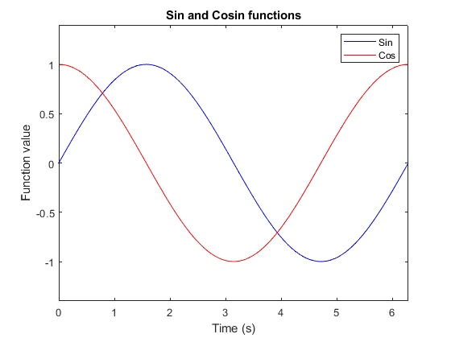

### Q1 – Throwing a Ball

The ball hits the ground at a distance of 2.582108e+00 meters.

### Q2 – Convergence of an Infinite Series

### Q2.1 – Semilog Plot

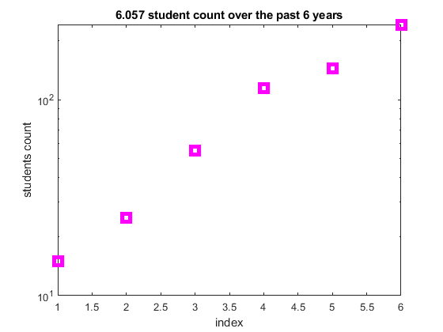

### Q2.2 – Subplot and Axis Modes

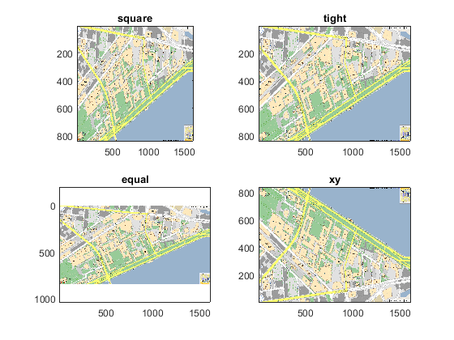

### Q2.3 – Bar Graph

### Q2.4 – Interpolation and surface plots

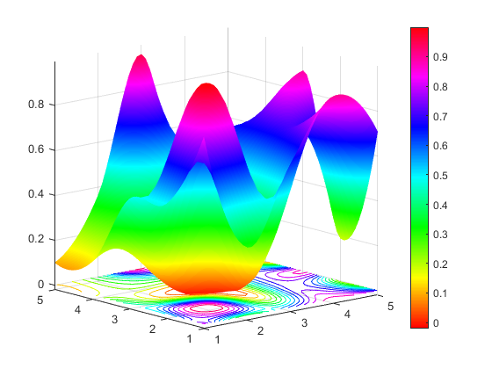

### Q2.5 – Fun with Find

>> x

x =

1 2 3 4

-4 -3 -2 -1

>> val

val =

0

>> findNearest(x, val)

ans =

1

8

### Q2.6 – Loops and Flow Control

>> loopTest(10)

1 is NOT divisible by 2 or 3

2 is divisible by 2

3 is divisible by 3

4 is divisible by 2

5 is NOT divisible by 2 or 3

6 is divisible by 2 AND 3

7 is NOT divisible by 2 or 3

8 is divisible by 2

9 is divisible by 3

10 is divisible by 2

### Q2.7 – Smoothing Filter

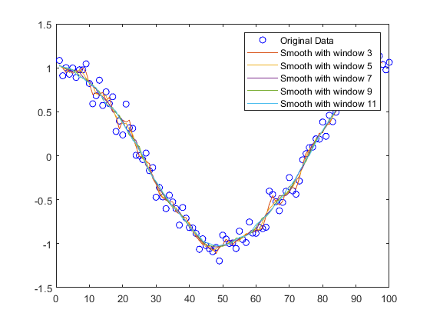

### Q2.8 – Plot a Circle

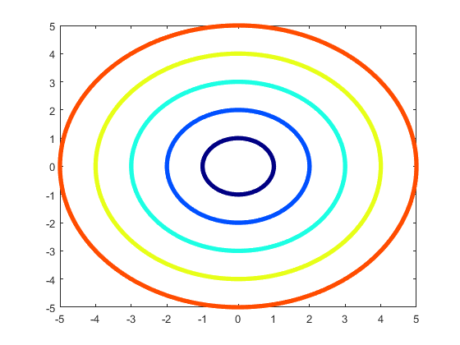

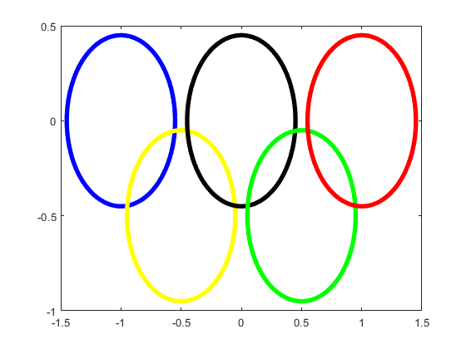

### Q2.9 – Functions

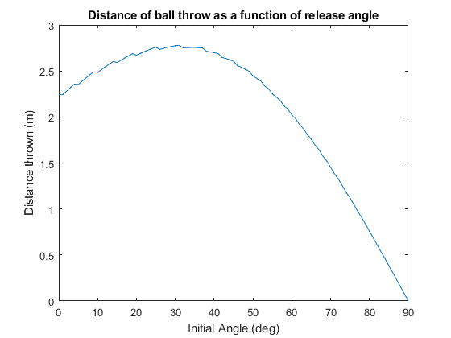

### Q2.10 – Smoothing nonuniformly sampled data

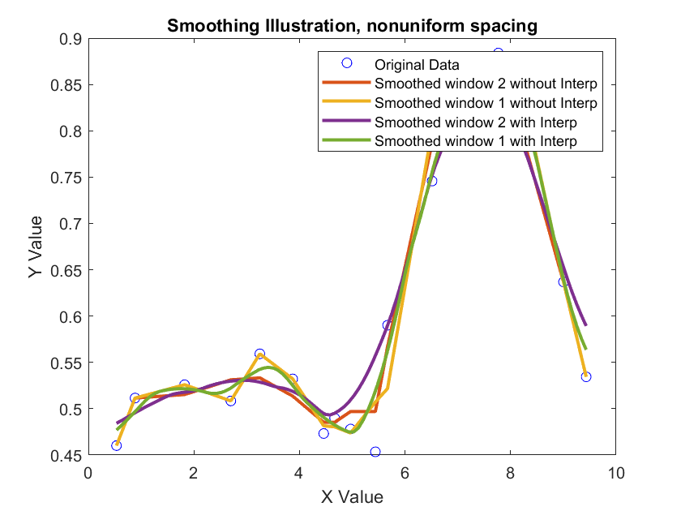

### Q2.11 - Buy and sell a stock

endValueInit100 =

100

endValueInit100K =

6.1231e+07